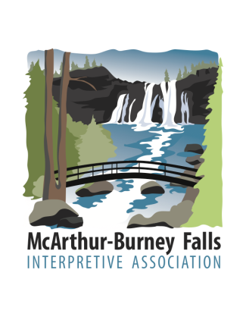
MISSION STATEMENT

The McArthur Burney Falls Interpretive Association (MBFIA) is an all-volunteer non-profit education organization that provides assistance and funding for activities which enhance the quality of visits to McArthur Burney Falls Memorial State Park, Castle Crags State Park and Ahjumawi Lava Springs State Park. The association was founded in 1984 to promote greater appreciation of the cultural and natural history of the region.
MBFIA raises funds to support educational and interpretive activities, including interpretive personnel, and a printed Visitor Guide provided free to visitors. MBFIA manages the Visitor Center Gift Shop. Funds are raised through the sale of firewood, advertising in the Visitor Guide, the operation of the Visitor Center gift shop, and most importantly, donations from friends and visitors.

